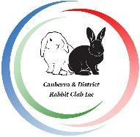 GOULBURN SHOW 2024 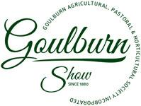

RABBIT SHOW SCHEDULE

Canberra & District Rabbit Club Inc in conjunction with the Goulburn Agricultural, Pastoral & Horticultural Society present the annual Goulburn Show Rabbit Show.

Date: Sunday 3rd March 2024

Judges: Susan Batho & Loren Stavens. Three Star Show

Venue: Basketball Stadium, Goulburn Showgrounds,
Braidwood Road, Goulburn. Entry through Gate 5.

Entries close: Sunday 25 ^{th} February 2023. No late entries.

Entries to: canberrarabbitclubsecretary@gmail.com

Vetting in: From 8:00 am to 9:30 am

Judging: 10 am sharp

Parking: No parking on grounds but plenty of parking just outside the showgrounds.

The rabbit shows will be held in the Basketball Stadium. Tables and chairs will be provided by the show society.
Cars cannot be driven on to the grounds, but it is a short walking distance over flat ground from the parking area outside the grounds to the Stadium. There is a ramp entrance to the Stadium for those with trolleys.

Entrance is through Gate 5. This is open from 7am to 8.30am sharp and manned for exhibitors to enter but once it is closed, you will have to use the general entrance.

The Stadium has toilets. There are a number of food and coffee stands under the skillion outside the Stadium.

The Stadium can get quite warm on very hot days from midday onwards so bring a spray bottle of water for your rabbits.

Animals will be expected to remain at the show until the end of the day (around 5pm).

Pet Friendly Accommodation:
Alpine Heritage Motel, 248 Sloane St., Goulburn 4821 2930
Willows Motel, 21 Sydney Rd, Goulburn 4821 4322
Governors Hill Motel, 61 Sydney Rd., Goulburn 4821 1766
South Hill Dairy (2 houses) 3kms from Goulburn 0411 131 515

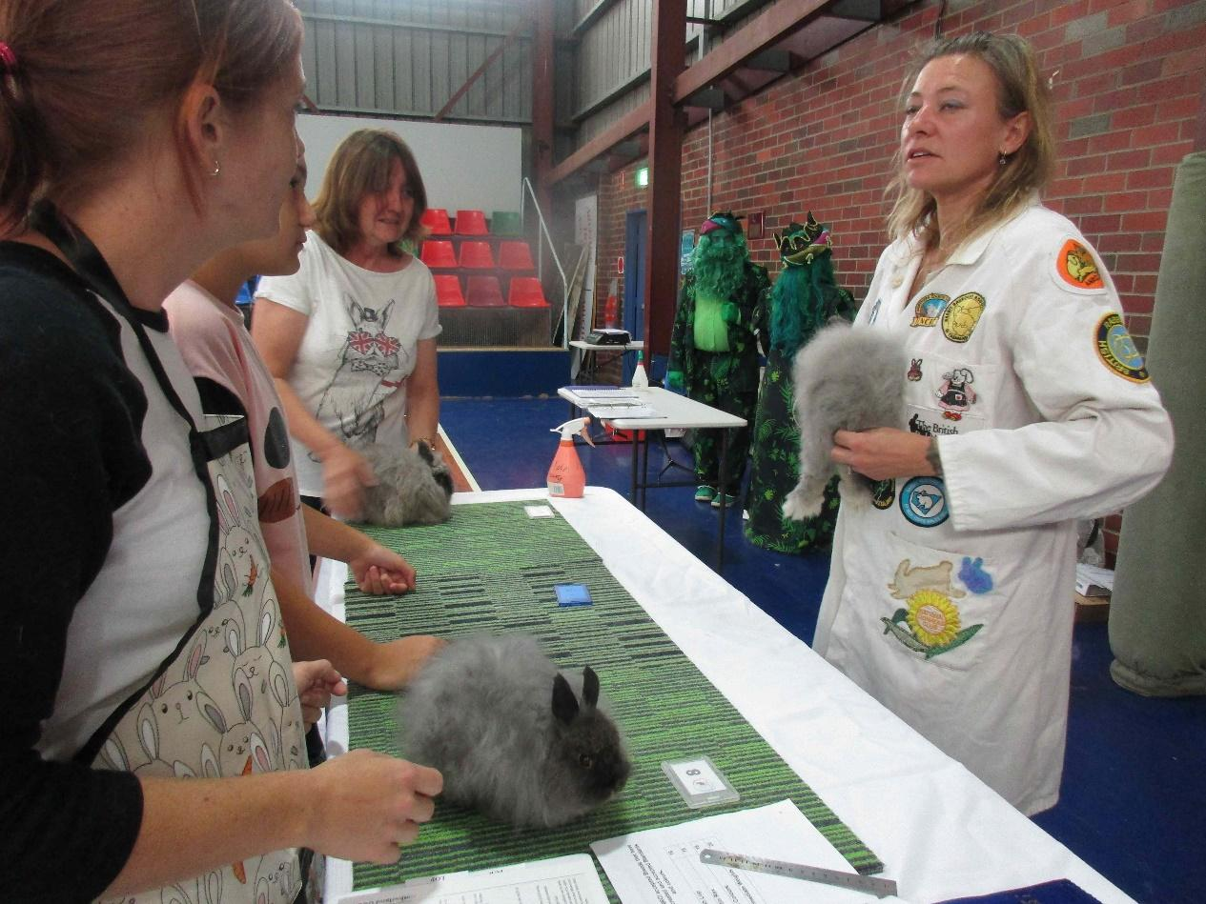

SCHEDULE of CLASSES
FANCY SECTION
BREED COLOUR K J A
English Angora | REW | 1 | 2 | 3
 | Self | 4 | 5 | 6
 | Shaded | 7 | 8 | 9
 | Any Other Colour | 10 | 11 | 12
Dutch | Self (Black, Blue, Chocolate, Lilac) | 13 | 14 | 15
 | Any Other Colour | 16 | 17 | 18
Tri-colour Dutch | Tri Colour | 19 | 20 | 21
English | Any Colour | 22 | 23 | 24
Harlequin | Harlequin | 25 | 26 | 27
 | Magpie | 28 | 29 | 30
Netherland Dwarf | REW | 31 | 32 | 33
 | Self | 34 | 35 | 36
 | Shaded | 37 | 38 | 39
 | Agouti | 40 | 41 | 42
 | Tan Pattern | 43 | 44 | 45
 | Any Other Colour | 46 | 47 | 48
Polish | REW | 49 | 50 | 51
 | Self | 52 | 53 | 54
 | Shaded | 55 | 56 | 57
 | Agouti | 58 | 59 | 60
 | Tan Pattern | 61 | 62 | 63
 | Any Other Colour | 64 | 65 | 66
Tan | Black Tan, Chocolate Tan | 67 | 68 | 69
 | Blue Tan, Lilac Tan | 70 | 71 | 72
Thrianta | Red | 73 | 74 | 75
Jersey Wooly | REW | 76 | 77 | 78
 | Any Other Colour | 79 | 80 | 81
Flemish Giant (BRC) | Steel | 82 | 83 | 84
Flemish Giant Intermediate | Steel |  |  | 85
Flemish Giant (ARBA) | Black, Blue, Fawn, Light Grey, Sandy, Steel Grey, White | 86 | 87 | 88

LOP SECTION
BREED COLOUR K J A
Cashmere Lop | REW | 89 | 90 | 91
 | Self | 92 | 93 | 94
 | Shaded | 95 | 96 | 97
 | Agouti | 98 | 99 | 100
 | Tan Pattern | 101 | 102 | 103
 | Any Other Colour | 104 | 105 | 106
Miniature Cashmere Lop | REW | 107 | 108 | 109
 | Self | 110 | 111 | 112
 | Shaded | 113 | 114 | 115
 | Agouti | 116 | 117 | 118
 | Tan Pattern | 119 | 120 | 121
 | Any Other Colour | 122 | 123 | 124
Dwarf Lop | REW | 125 | 126 | 127
 | Self | 128 | 129 | 130
 | Shaded | 131 | 132 | 133
 | Agouti | 134 | 135 | 136
 | Tan Pattern | 137 | 138 | 139
 | Any Other Colour | 140 | 141 | 142
German Lop | REW | 143 | 144 | 145
 | Agouti | 146 | 147 | 148
 | Any Other Colour | 149 | 150 | 151
Miniature Lop | REW | 152 | 153 | 154
 | Self | 155 | 156 | 157
 | Shaded | 158 | 159 | 160
 | Agouti | 161 | 162 | 163
 | Tan Pattern | 164 | 165 | 166
 | Any Other Colour | 167 | 168 | 169
Miniature Plush Lop | All Colours | 170 | 171 | 172
Plush Lop | All Colours | 173 | 174 | 175

FUR SECTION

BREED COLOUR K J I* A
British Giant | White | 176 | 177 | 178 | 179
 | Brown Grey | 180 | 181 | 182 | 183
 | Black, Blue, Opal | 184 | 185 | 186 | 187
 | Dark Steel Grey | 188 | 189 | 190 | 191
Californian | Normal, Chocolate, Blue, Lilac | 192 | 193 | n/a | 194
Chinchilla | Chinchilla | 195 | 196 | n/a | 197
Chinchilla Giganta | Chinchilla | 198 | 199 | n/a | 200
Fox | Black, Chocolate | 201 | 202 | n/a | 203
 | Blue, Lilac | 204 | 205 | n/a | 206
New Zealand White | White, Black Blue | 207 | 208 | n/a | 209
New Zealand Red | Red | 210 | 211 | n/a | 212
Siamese Sable | Light, Medium, Dark Siamese Sable | 213 | 214 | n/a | 215
Marten Sable | Medium, Dark Marten Sable | 216 | 217 | n/a | 218
Satin | Ivory | 219 | 220 | n/a | 221
 | Self | 222 | 223 | n/a | 224
 | Shaded | 225 | 226 | n/a | 227
 | Agouti | 228 | 229 | n/a | 230
 | Tan Pattern | 231 | 232 | n/a | 233
 | Any Other Colour | 234 | 235 | n/a | 236
Smoke Pearl | Any Colour | 237 | 238 | n/a | 239
Swiss Fox | White | 240 | 241 | n/a | 242
 | Any Other Colour | 243 | 244 | n/a | 245
Miniature Satin | Ivory | 246 | 247 | n/a | 248
 | Any Other Colour | 249 | 250 | n/a | 251
Fur AOV |  | 252 | 253 | n/a | 254
*Intermediate: Aged 5-11 months

REX SECTION
BREED COLOUR K J A
Standard Rex | Ermine | 255 | 256 | 257
 | Self | 258 | 259 | 260
 | Shaded | 261 | 262 | 263
 | Tan Pattern | 264 | 265 | 266
 | Agouti | 267 | 268 | 269
 | Any Other Colour | 270 | 271 | 272
Miniature Rex | Ermine | 273 | 274 | 275
 | Self | 276 | 277 | 278
 | Shaded | 279 | 280 | 281
 | Tan Pattern | 282 | 283 | 284
 | Agouti | 285 | 286 | 287
 | Any Other Colour | 288 | 289 | 290
Satin Rex | All Colours | 291 | 292 | 293
Rex AOV |  | 294 | 295 | 296

K J A
Unrung | All Colours | 313 | 313 | 313
Owner Bred | All Colours | 314 | 314 | 314

Non Standard Breeds and  Breeds in Development | All Colours | 315 | 316 | 317
JUNIOR HANDLER U/10 |  | 401
JUNIOUR HANDLER U/16 |  | 402

COLOUR GUIDE
AGE DEFINITION

Adult: Over 5 months.
Intermediate: 5- 11 months (British Giant)
Junior: from 14 weeks to 5 months of age.
Kitten: from 10 weeks to 14 weeks of age.

COLOUR DEFINITIONS — Fur, Fancy and Lop Only
Red Eyed White (REW) = as pure white as possible with ruby red eyes colour.
Ivory = (specific to Satins) Eye colour to be red or blue.
Self = Black, Blue, Brown/Chocolate/Havana, Lilac, Blue Eyed White (BEW).
Shaded = Siamese Sable (dark, medium or light), Smoke Pearl/Siamese Smoke, Seal Point, Blue Point, Iron Grey, Chocolate Tort, Sooty Fawn/Tortoiseshell, Beige.
Tan Pattern = Fox, Otter and Tan (in black, blue, chocolate or lilac), Marten Sable (light, medium, dark), Smoke Pearl Marten/Siamese Smoke Marten (light, medium, dark).
Agouti Pattern = Agouti/Castor/Brown Grey, Red Agouti, Opal, Lynx, Chinchilla, Cinnamon, Squirrel.
Any Other Colour (AOC) = Orange, Fawn, Red, Steel (dark, light or dark steel grey), Himalayan, butterfly pattern, Dalmation and broken pattern (in bi-colour or tri-colour), harlequin patterns or any other colour not already mentioned so long as it conforms to the normal pattern of accepted colours of other breeds excluding broken pattern.

COLOUR DEFINITIONS — Standard Rex and Mini Rex Only
Ermine = as pure white as possible with ruby red eye colour.
Self = Black, Blue, Havana, Lilac, Nutria
Shaded = Siamese Sable, Siamese Smoke Pearl, Smoke Pearl Marten, Seal, Tortoiseshell.
Tan Pattern = Marten Sable, Marten Seal, Orange, Fawn, Fox, Otter and Tan (in black, blue, chocolate or lilac)
Agouti Pattern = Agouti, Castor, Chinchilla, Cinnamon, Lynx, Opal

